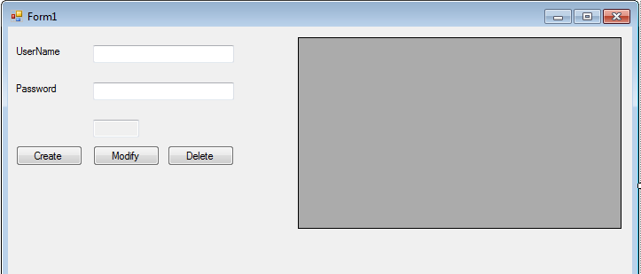

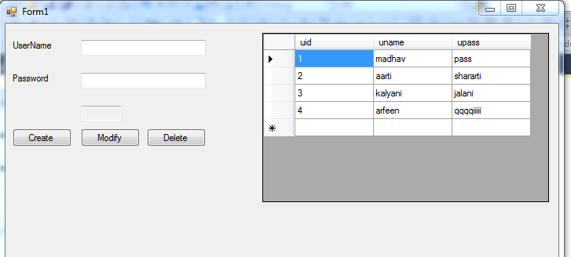

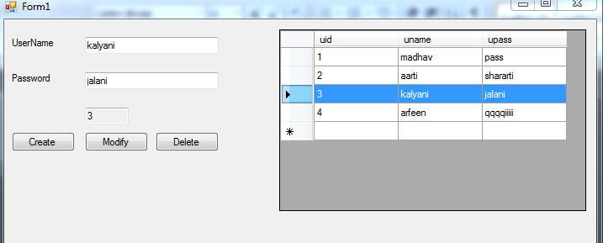

Imports System.Data

Imports System.Data.SqlClient

Public Class Form1

Dim ds As New DataSet

Private conString As String = "Data Source=.\SQLEXPRESS;AttachDbFilename='C:\Users\admin\Documents\Visual Studio 2010\Projects\addupdatedelete\addupdatedelete\myDB.mdf';Integrated Security=True;Connect Timeout=30;User Instance=True"

Private Sub Form1_Load(ByVal sender As System.Object, ByVal e As System.EventArgs) Handles MyBase.Load

txtId.Text = ""

txtpasswd.Text = ""

txtuname.Text = ""

GetData()

End Sub

Private Sub GetData()

Dim con As New SqlConnection(conString)

Dim sql As String = "Select * from userTable"

Dim da As New SqlDataAdapter(sql, con)

con.Open()

da.Fill(ds, "userTable")

con.Close()

DataGridView1.DataSource = ds

DataGridView1.DataMember = "userTable"

End Sub

Private Sub btncreate_Click(ByVal sender As System.Object, ByVal e As System.EventArgs) Handles btncreate.Click

If (txtuname.Text <> "" And txtpasswd.Text <> "") Then

Dim txtName = txtuname.Text

Dim txtPass = txtpasswd.Text

Dim con As New SqlConnection(conString)

Dim sql As String = "insert into userTable(uName,uPass) values('" & txtName & "','" & txtPass & "')"

con.Open()

Dim cmd As New SqlCommand(sql, con)

If (cmd.ExecuteNonQuery()) Then

MsgBox("Data inserted successfully!")

Else

MsgBox("Sorry!! Could not insert data.")

End If

con.Close()

DataGridView1.DataSource = Nothing

ds.Clear()

GetData()

txtId.Text = ""

txtpasswd.Text = ""

txtuname.Text = ""

Else

MsgBox("Please enter some data to create user")

End If

End Sub

Private Sub DataGridView1_CellClick(ByVal sender As Object, ByVal e As System.Windows.Forms.DataGridViewCellEventArgs) Handles DataGridView1.CellClick

Dim i As Integer

i = DataGridView1.CurrentRow.Index

Me.txtId.Text = DataGridView1.Item(0, i).Value

Me.txtuname.Text = DataGridView1.Item(1, i).Value

Me.txtpasswd.Text = DataGridView1.Item(2, i).Value

End Sub

Private Sub btnModify_Click(ByVal sender As System.Object, ByVal e As System.EventArgs) Handles btnModify.Click

If (txtId.Text <> "") Then

Dim tName = txtuname.Text

Dim tPass = txtpasswd.Text

Dim tID = CInt(txtId.Text)

Dim con As New SqlConnection(conString)

Dim sql As String = "update userTable set uName='" & tName & "',uPass='" & tPass & "' where uid = " & tID

con.Open()

Dim cmd As New SqlCommand(sql, con)

If (cmd.ExecuteNonQuery()) Then

MsgBox("Data updated successfully!")

Else

MsgBox("Sorry!! Could not update data.")

End If

con.Close()

DataGridView1.DataSource = Nothing

ds.Clear()

GetData()

txtId.Text = ""

txtpasswd.Text = ""

txtuname.Text = ""

Else

MsgBox("Empty update not allowed")

End If

End Sub

Private Sub btnDelete_Click(ByVal sender As System.Object, ByVal e As System.EventArgs) Handles btnDelete.Click

If (txtId.Text <> "") Then

Dim tID = CInt(txtId.Text)

Dim con As New SqlConnection(conString)

Dim sql As String = "delete from userTable where uid = " & tID

con.Open()

Dim cmd As New SqlCommand(sql, con)

If (cmd.ExecuteNonQuery()) Then

MsgBox("Data deleted successfully!")

Else

MsgBox("Sorry!! Could not delete data.")

End If

con.Close()

DataGridView1.DataSource = Nothing

ds.Clear()

GetData()

txtId.Text = ""

txtpasswd.Text = ""

txtuname.Text = ""

Else

MsgBox("Please select a row from grid")

End If

End Sub

End Class